SOLUTION

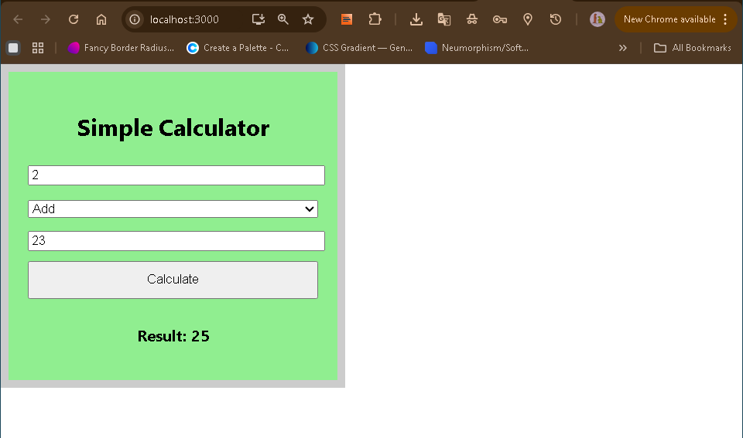

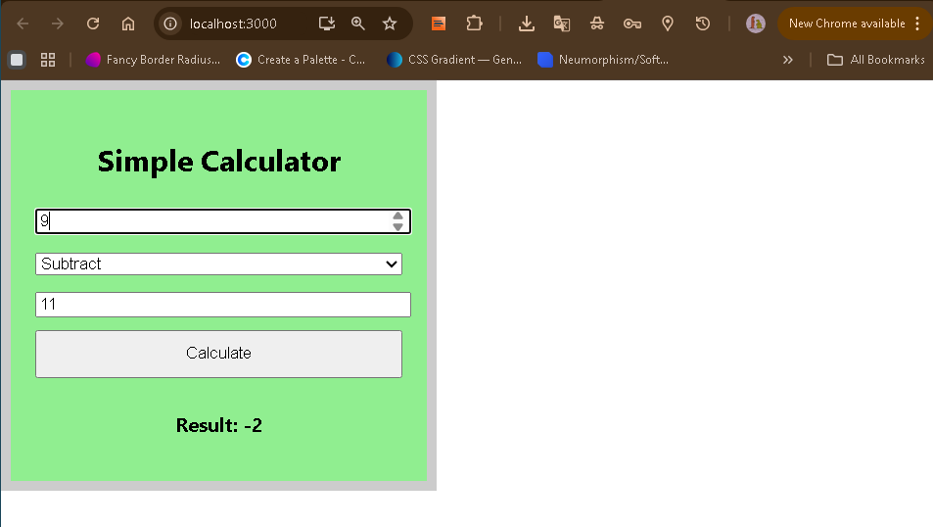

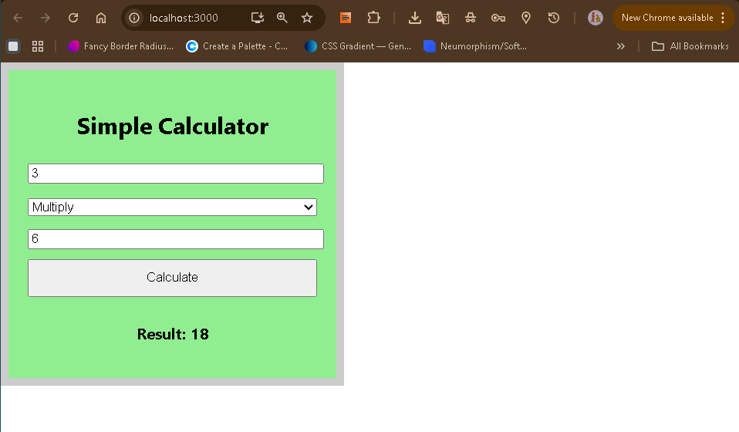

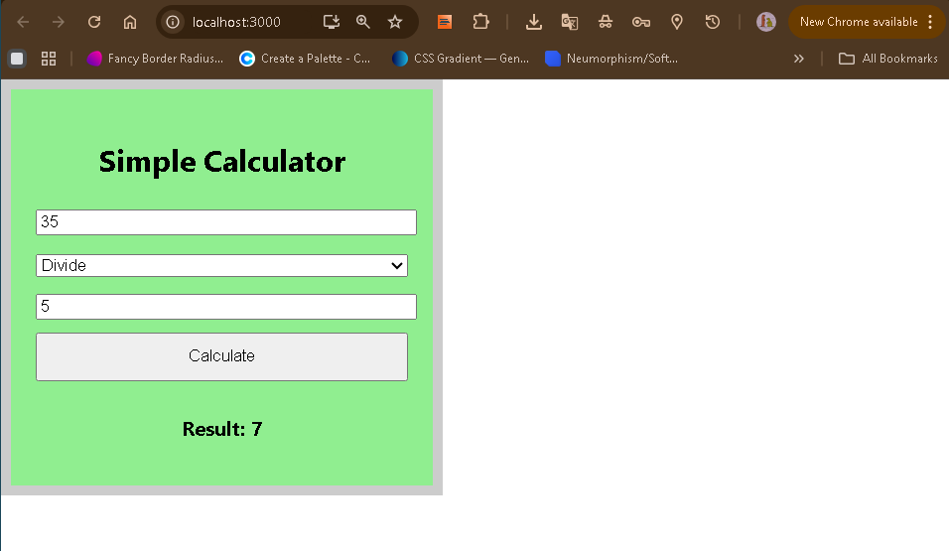

The calculator is constructed as a functional React component named Calculator. It utilizes normal html input to take a number, second number, and operator in between, all of which it processes by calling the function calculate(). This function relies on document.getElementById to get both numbers and the chosen operator value, parseFloat to ensure that both values can be used for numerical calculations and a switch statement to execute the required mathematical function. The result is displayed in real time on the page after Calculate is pressed.

